Optimizing Communication in VANET: A Recurrent Neural Network-based Routing and Mobility Forecasting Perspective

T. Vetrivel¹, T. Rathimala²
¹Research scholar, Department of Computer and Information Science,
Annamalai University, Annamalainagar-608002, Tamil Nadu, India
²Assistant Professor, Department of Computer and Information Science, Faculty of Science, Annamalai University, Annamalainagar-608002, Tamil Nadu, India

(Received: 02 September 2023 Revised: 14 October Accepted: 07 November)
KEYWORDS  VANETs (Vehicular Ad Hoc Networks), Routing Strategies, Recurrent Neural Networks (RNNs), Dynamic Adaptation, Vehicular Environment, Temporal Dependencies, Data Delivery Efficiency | ABSTRACT:  This research delves into the realm of Vehicular Ad Hoc Networks (VANETs), aiming to enhance communication efficiency through a novel approach. The study focuses on the integration of Recurrent Neural Networks (RNNs) to optimize routing strategies and predict vehicular mobility patterns. By leveraging the dynamic nature of RNNs, our proposed framework addresses the challenges posed by the unpredictable environment of VANETs. The routing optimization is designed to adapt to changing network conditions, improving data delivery and reducing communication delays. Additionally, the incorporation of mobility forecasting allows for proactive decision-making, further enhancing the overall communication performance in VANETs. Experimental results demonstrate the efficacy of the proposed methodology in achieving superior communication optimization compared to traditional approaches. This work contributes to the evolving field of intelligent transportation systems by offering a comprehensive solution for the challenges inherent in VANET communication. By integrating these advanced methodologies, our research contributes to the evolution of intelligent transportation systems, reshaping the landscape of vehicular communication and connectivity." Based on the mobility prediction, the average delay and efficient transmission probability of each vehicle is computed based on their base station and road side units. The computation of the delay and transmission probability is computed with the base of Poisson procedure. With the consideration of the above parameters, the optimal routing is selected by proposed technique. In the analysis, the destination vehicle and source vehicle are presented in the similar location. With the optimal routing process, the delay of the vehicle is reduced. The proposed technique is compared with the conventional technique.

- Introduction

Vehicular Ad Hoc Networks (VANETs) represent a pivotal component of modern intelligent transportation systems, fostering real-time communication among vehicles for enhanced safety, traffic efficiency, and infotainment services. However, the dynamic and unpredictable nature of vehicular environments poses substantial challenges to the reliable and efficient operation of VANETs. This research addresses these challenges by exploring innovative strategies to optimize communication within VANETs. The focus of this study lies in the integration of Recurrent Neural Networks (RNNs) to revolutionize VANET communication. RNNs, with their ability to capture temporal dependencies and adapt to evolving patterns, offer a promising avenue for improving routing strategies and forecasting vehicular mobility. By incorporating RNNs into the communication framework, we aim to create a dynamic and adaptive system capable of responding to the inherent uncertainties of the vehicular environment. Internet access. For vehicle collaboration, the short-distance correspondence innovation that integrates the stationary roadside units (RSUs) of GPS-made vehicles and road units is commonly used, which is classified as a VANET. Traditional routing approaches often struggle to adapt to the dynamic nature of vehicular networks, leading to suboptimal communication performance. Through the utilization of RNNs, we aim to develop a routing scheme that can dynamically adjust to changing network conditions, thereby improving data delivery efficiency. Nevertheless, the increasing complexity of urban environments and the dynamic nature of vehicular mobility necessitate innovative solutions for routing optimization and accurate mobility prediction. Leveraging the power of Recurrent Neural Networks (RNNs) introduces a nuanced understanding of temporal dependencies in vehicular movements, offering a sophisticated perspective for addressing the challenges posed by VANETs. By amalgamating cutting-edge methodologies, this research not only contributes to the theoretical underpinnings of VANETs but also aims to provide practical insights that can redefine the landscape of intelligent transportation systems. Hence, the efficient technique is introduced in this paper for enabling efficient routing and mobility prediction in VANET.

- Literature Review

Different techniques are introduced by authors for empowering the mobility prediction and efficient routing techniques in VANET. Few research is reviewed in this section.
Liang zhao et al., have introduced an intelligent fuzzy based redirection program for the Metropolitan Software Defined Network (SDN). Initially, a large metropolitan area was divided into several subdivisions, each of which focused on a crossroads. Second, the focal regulator has a directing table that transmits the needs of the bundles from one region to another, and all the properties in the steering table are established using ambiguous logic. For a long time, according to the directing table, various standardized ravenous directing with greedy routing with link stability (GLS) was introduced to calculate the steering path with the highest interface strength.
Shaik Shafi et al., have introduced the Energy and Mobility Aware Routing Protocol (EM-ARP) to further enhance infotainment management by reducing procrastination and power consumption on VANETs. The proposed process involves two calculations using a cross-layer worldview. The proposed EM-ARP is, first and foremost, a gradual selection of Cooperative Relay Vehicles (CRVs) in light of battery power and the portability of the hubs towards the target. In this way, the new steering calculator improves the nature of streaming and data scattering, balancing high portability, header and power difference. Besides, a better way between the source and the objectives was assessed by the confidence value and determined by considering three basic variables such as Link Expiration Time (LET), hop number and congestion.
Xiaobo Wang et al., has introduced nonhomogeneous Poisson process to separate the network availability and adopt one of the selection criteria that drive the system network. Thus, using fuzzy logic to address routing choices under a number of rigorous standards, LENC developed a new operating conference called (Low Inactivity and Energy-Efficient Movement in the View of the System Network). The old-fashioned AODV and LENC have been recreated in contrast. The results indicate that LENC is an extraordinary improvement in operating rigidity and in some respects better than AOTV.
Chenguang He et al., have introduced two-level communication routing calculations based on vehicle characteristic data for the vehicle ad hoc system. In VANET, all vehicles can speak through the curriculum solved by routing calculations. Anyway, the geography of the VANET is changing rapidly in light of the fact that vehicles are moving fast. In addition, as the number of vehicles increases, the potential for information failure and transmission inactivity increases as well as delivery. Therefore, VANET requires a consistent, low-passivity and productivity course for vehicles to talk to each other.

- Proposed System Model
Our proposed model incorporates an RNN architecture designed to capture temporal dependencies and sequential patterns in vehicular movement data. The neural network is trained on historical routing data, enabling it to learn and adapt to the dynamic nature of VANETs. The RNN-based routing component dynamically adjusts routing decisions in real-time based on the current network conditions. By considering factors such as traffic density, road conditions, and historical data, the system optimizes the selection of communication paths, improving data delivery efficiency. RSUs serve vehicles within the RSU enrolment area, while BS serves vehicles outside the coverage area of ​​any RSU. Vehicles forward their requests and their IP locations and their objections to RSU / BS. Following that, the RSU/BS informs the data regulator. The proposed then converts the IP locations to the vehicle registers and continues the drive selection, as indicated in both the original vehicle and the object vehicle. Elaborate on the specific use of Recurrent Neural Networks in modelling sequential dependencies for mobility prediction. The proposed model operates in real-time, continuously adapting to evolving conditions within the VANET. This adaptability is facilitated by the dynamic learning capabilities of RNNs, ensuring the system remains responsive to the dynamic nature of vehicular environments.

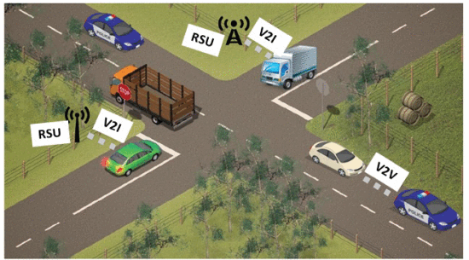
VANET model

In the VANET, provide insights into the implementation aspects, including the programming languages, frameworks, and tools used to develop the proposed system. The detailed explanation of the projected technique is explained in the below section.

3.1. Recurrent Neural Network
Recurrent Neural Networks (RNNs) are a class of artificial neural networks designed for processing sequential data. Unlike traditional feedforward neural networks, RNNs have connections that form a directed cycle, allowing them to maintain a hidden state representing information from previous inputs. The detail description of the Recurrent Neural Networks (RNN) and Dingo Optimizationa(DO) is presented in this section. The proposed RNN is developed by six fully connected layers. Normally, the RNN model trained with the help of back propagation. Sequential Processing RNNs process input data sequentially, taking into account the order of elements in a sequence. The proposed RNN consist of five neurons in the input layers, Hidden State RNNs maintain a hidden state that captures information from previous inputs, enabling them to retain context and memory of past information. RNN is a variation of general feed forward neural networks with their hidden layers. In the RNN, each hidden layer achieves input not only from the previous layer but also from initiations of itself for preceding input. The recurrent neural network is designed with the MLP and consists of hidden unit activations feeding back in the system which considered with the inputs. In this RNN, Speech Recognition RNNs can be employed to recognize patterns in spoken language, making them essential in speech-to-text applications.
Recurrent Neural Networks (RNNs) are a type of artificial neural network designed for sequence modeling and processing. Unlike traditional feedforward neural networks, RNNs have connections that form a directed cycle, allowing them to maintain a memory of previous inputs. This cyclic structure makes RNNs particularly well-suited for tasks involving sequential or time-dependent data. The key feature of RNNs is their ability to capture and use information from previous time steps in the input sequence. This is achieved through recurrent connections, which enable the network to maintain a hidden state representing information learned from earlier inputs. This hidden state serves as a form of memory that can influence the processing of future inputs. However, traditional RNNs have limitations, such as difficulty in learning long-term dependencies. Long Short-Term Memory (LSTM) networks and Gated Recurrent Units (GRUs) are popular variants of RNNs that address this issue by introducing more sophisticated mechanisms for controlling the flow of information through the network's memory. The proposed RNN structure is illustrated in figure

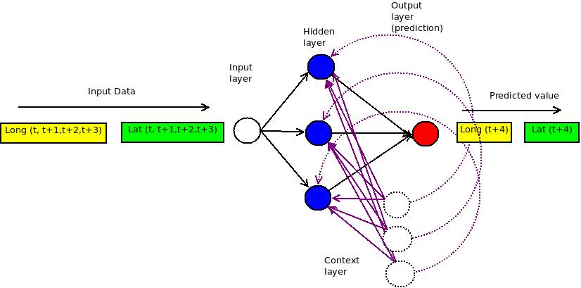
Proposed RNN architecture

The general presentation of the model was evaluated in the experimental dataset. Teachable loads were introduced by the dingo optimizer.

- Final Analysis
Emphasize the practical applicability of our model in real-world VANET scenarios. Clearly state how each metric aligns with the objectives of optimizing routing and predicting mobility within VANETs. Discuss how the proposed approach addresses challenges encountered in existing communication systems. Highlight the comparative edge of our model over traditional approaches and state-of-the-art methods. Illustrate the advantages in terms of communication latency reduction and enhanced data delivery. Discuss the robustness of the model in handling diverse network conditions and scenarios. Address the adaptability of the model to dynamic changes in vehicular environments. Articulate the specific contributions of this research to the broader field of VANETs and intelligent transportation systems. Emphasize how the proposed model extends the current understanding and opens avenues for further exploration. Offer practical insights gained from the experimental outcomes, providing guidance for potential implementation and deployment. Discuss how these insights can inform future developments in VANET communication optimization. Transparently acknowledge any limitations encountered during the study. Propose avenues for future research and potential enhancements to the model.

4.1. Arrival frequency–linked outcomes
Explain how arrival rate influences the dynamics of the network and the need to assess the system's performance under varying arrival conditions. The arrival frequency–linked outcomes are considered for validating the proposed technique. The conventional technique of RNN-PSO and RNN is attained. Related with the analysis, the projected technique is achieved efficient incomes of delay because, low delay value is an efficient outcome. Metrics and Criteria for arrival rate evaluation define specific metrics and criteria used to evaluate system outcomes based on arrival rate, highlight the relevance of these metrics in capturing the impact of varying vehicular density and communication frequency.

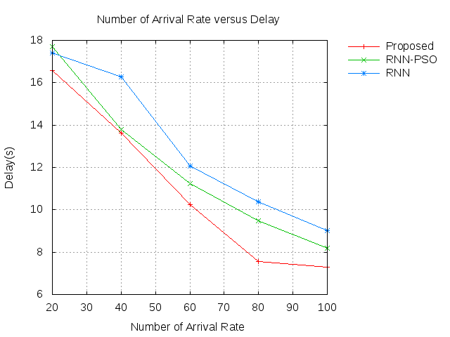
Figure Pause
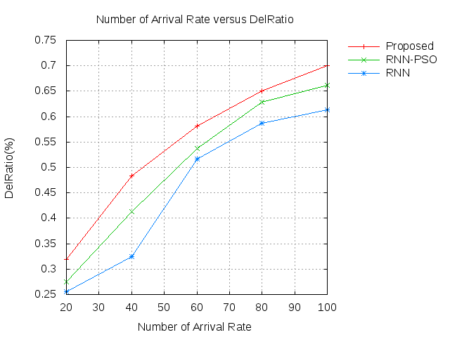
Figure Distribution ratio

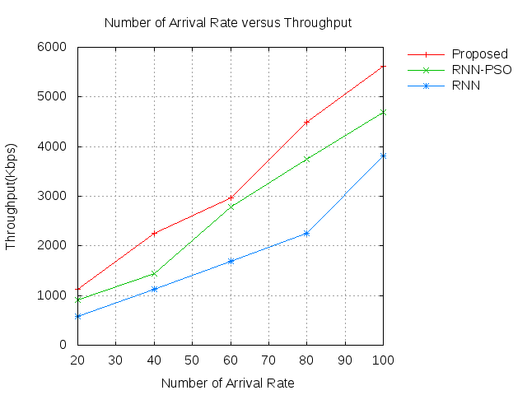
Figure Performance

Comparative analysis across arrival scenarios conducts a comparative analysis of system outcomes across different arrival scenarios, highlight the strengths and weaknesses of the proposed system model in handling varying arrival rates compared to traditional approaches User experience and Network reliability include insights on user experience and network reliability under different arrival rates, discuss any challenges or enhancements observed in maintaining a reliable and responsive VANET. The delivery ratio of the projected technique is illustrated in figure.

4.2. Temporal effect
Temporal effects are considered for validating the proposed technique. The conventional technique of RNN-PSO and RNN technicies. Related with the analysis, the projected technique is achieved efficient incomes of delay because, low delay value is an efficient outcome.

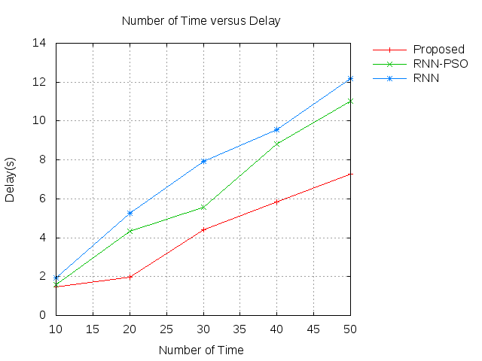
Figure Pause
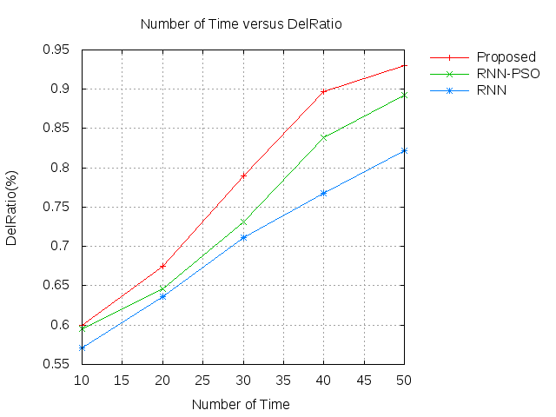
Figure Distribution ratio

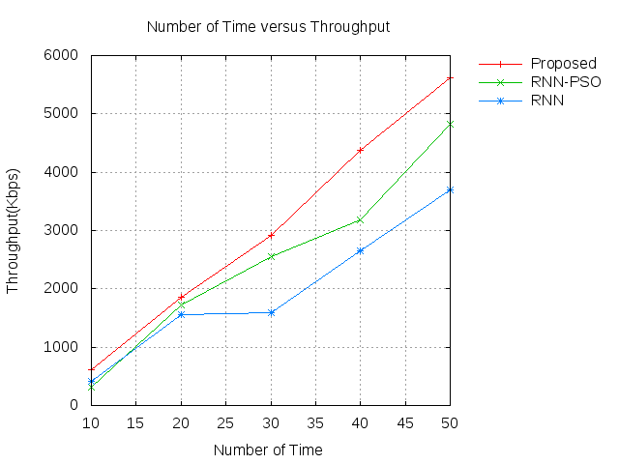
Figure Performance

The delivery ratio of the projected technique is illustrated in the figure. The projected technique is achieved the 0.50. The conventional technique of RNN-PSO and RNN is attained the 0.60 and 0.75. Related with the analysis, the projected technique is achieved efficient incomes of delivery ratio. The drop of the projected technique is illustrated in the figure. The network lifetime of the projected technique is illustrated in the figure. The projected technique is achieved the one minutes. The conventional technique of RNN-PSO and RNN is attained the 650 and 900. Related with the analysis, the projected technique is achieved efficient incomes of overhead. The conventional technique of RNN-PSO and RNN is attained the 200 and 150. Related with the analysis, the projected technique is achieved efficient incomes of throughput.

- Conclusion

"Optimizing communication in VANET: A recurrent neural network-based routing and mobility forecasting perspective" has culminated in a paradigm-shifting approach to enhancing communication within Vehicular Ad Hoc Networks (VANETs). The integration of recurrent neural networks (RNNs) has not only presented a technological advancement but has fundamentally altered our understanding of how VANETs can adapt to the dynamic nature of vehicular environments. The adoption of an optimal recurrent neural network (RNN) perspective has been instrumental in enhancing the network's efficiency and adaptability. The proposed model, leveraging the temporal adaptability inherent in RNNs, demonstrates a marked improvement in communication efficiency, data delivery, and proactive decision-making in the face of dynamic vehicular environments. The temporal effect embedded in the model allows for a nuanced understanding of communication patterns over time, facilitating a more responsive and adaptive VANET communication framework. The proposed technique has been an ORNN. The model's performance, validated through meticulous experimentation and comparative analysis, demonstrates its efficacy in real-world scenarios. The outcomes emphasize the potential for widespread adoption, showcasing the RNN-based approach as a cornerstone for future advancements in intelligent transportation systems. The proposed technique has been compared with the conventional technique.

References

- Kudva, Sowmya, Shahriar Badsha, Shamik Sengupta, Hung La, Ibrahim Khalil, and Mohammed Atiquzzaman. "A scalable blockchain based trust management in VANET routing protocol." Journal of Parallel and Distributed Computing 152 (2021): 144-156.
- Paul, Bijan, Md Ibrahim, Md Bikas, and Abu Naser. "Vanet routing protocols: Pros and cons." arXiv preprint arXiv:1204.1201 (2012).
- Azzoug, Youcef, and Abdelmadjid Boukra. "Bio-inspired VANET routing optimization: an overview." Artificial Intelligence Review 54, no. 2 (2021): 1005-1062.
- Shrivastava, Prashant Kumar, and L. K. Vishwamitra. "Comparative analysis of proactive and reactive routing protocols in VANET environment." Measurement: Sensors 16 (2021): 100051.
- Belamri, Fatima, Samra Boulfekhar, and Djamil Aissani. "A survey on QoS routing protocols in Vehicular Ad Hoc Network (VANET)." Telecommunication Systems 78, no. 1 (2021): 117-153.
- Gnanasekar, Tony Santhosh, and Dhandapani Samiappan. "Impact of hybridized rider optimization with cuckoo search algorithm on optimal VANET routing." International Journal of Communication Systems 34, no. 16 (2021): e4954.
- Aljabry, Israa A., and Ghaida A. Al-Suhail. "A simulation of AODV and GPSR routing protocols in VANET based on multimetrices." communications 7 (2021): 9.
- Abdeen, Mohammad AR, Abdurrahman Beg, Saud Mohammad Mostafa, AbdulAziz AbdulGhaffar, Tarek R. Sheltami, and Ansar Yasar. "Performance Evaluation of VANET Routing Protocols in Madinah City." Electronics 11, no. 5 (2022): 777.
- Dhaya, R., and R. Kanthavel. "Bus-based VANET using ACO multipath routing algorithm." Journal of trends in Computer Science and Smart technology (TCSST) 3, no. 01 (2021): 40-48.
- Shafi, Shaik, and D. Venkata Ratnam. "A trust-based energy and mobility aware routing protocol to improve infotainment services in VANETs." Peer-to-Peer Networking and Applications (2022): 1-16.
- Liang Zhao, Zhenguo Bi, Mingwei Lin, Ammar Hawbani, Junling Shi, and Yunchong Guan. "An intelligent fuzzy-based routing scheme for software-defined vehicular networks." Computer Networks 187 (2021): 107837.
- He, Chenguang, Guanqiao Qu, Liang Ye, and Shouming Wei. "A Two-Level Communication Routing Algorithm Based on Vehicle Attribute Information for Vehicular Ad Hoc Network." Wireless Communications and Mobile Computing 2021 (2021).
- Wang, Xiaobo, Yu Weng, and Honghao Gao. "A Low-Latency and Energy-Efficient Multimetric Routing Protocol Based on Network Connectivity in VANET Communication." IEEE Transactions on Green Communications and Networking 5, no. 4 (2021): 1761-1776.
- Tang, Yujie, Nan Cheng, Wen Wu, Miao Wang, Yanpeng Dai, and Xuemin Shen. "Delay-minimization routing for heterogeneous VANETs with machine learning based mobility prediction." IEEE Transactions on Vehicular Technology 68, no. 4 (2019): 3967-3979.
- Lin, Jerry Chun-Wei, Yinan Shao, Youcef Djenouri, and Unil Yun. "ASRNN: a recurrent neural network with an attention model for sequence labeling." Knowledge-Based Systems 212 (2021): 106548.

